**Tesco UI Test**

Don’t stress about the challenge too much – it’s supposed to be fun and a way for us to get a feel for your level of experience.

Either zip your solution up and email it to us or put it on a public source repository (such as

GitHub) and give us the URL. In either case, we should be able to run your code with no crazy

steps.

**Problem**

Build a web page - using whatever tools, frameworks and techniques of your choosing - to achieve a similar result to the screen grab below. You can find the required JSON data required in the accompanying file data.json.

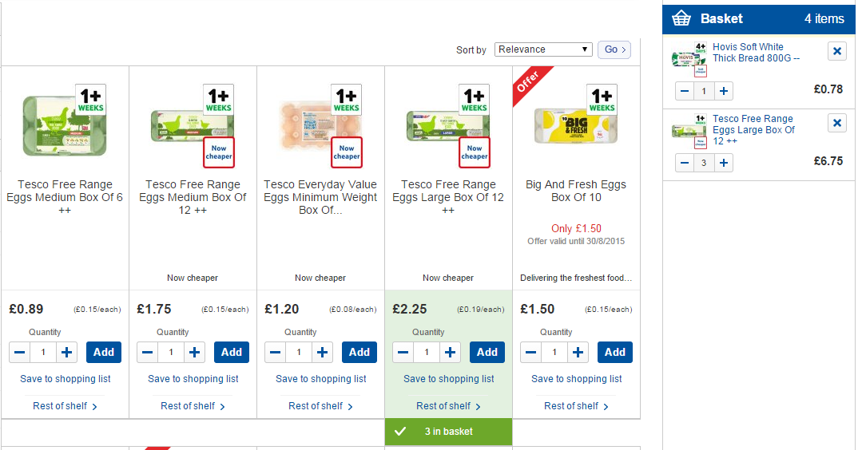

This Page should:

1. allow users to view and sort products (Client side)
2. results should display (at least) the following for each product
   * Name
   * Image
   * Price
   * Offers of Type Reward
   * Quantity of product in user basket
3. Allow a user to increment/decrement the number of that product in the basket (client-side)
4. Be developed with both mobile and desktop viewports in mind
5. Be accessible

**Task requirements**

* All requirements to be completed with an appropriate level of testing.
* Feel free to use whatever JavaScript, testing, mocking/stubbing frameworks you prefer, along with any other packages.
* Your code should be of production quality.
* Please include a readme file on how to get your application up and running